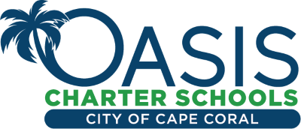
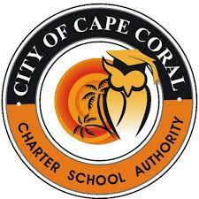

City of Cape Coral Charter School Authority Meeting Dates August 2022 – January 2023

All City of Cape Coral Charter School Authority Governing Board Regular Meetings are held at 5:30P.M., in Cape Coral City Council Chambers, at 1015 Cultural Park, Blvd., Cape Coral, FL 33990, unless otherwise notified.

MEETING DATES

AUGUST 16
SEPTEMBER 13
OCTOBER 11
NOVEMBER 8
DECEMBER 13
JANUARY 17, 2023

