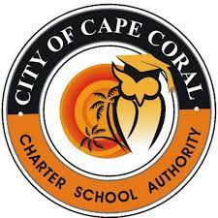

The next Regular Meeting of the City of Cape Coral Charter School Authority Governing Board will be held on Friday, November 18, 2022, at 10:00a.m., at Oasis Middle School – “Gator Garage,” 3507 Oasis Blvd., Cape Coral, Florida 33914.
Immediately following the Regular Meeting, the City of Cape Coral Charter School Authority will hold a “Strategic Plan 2021-2023 Recalibration Workshop” at 11:00a.m., or as soon thereafter, also at Oasis Middle School – “Gator Garage,” 3507 Oasis Blvd., City of Cape Coral, FL 33914.
In accordance with the Americans with Disabilities Act and Section of 286.26, Florida Statutes, persons with disabilities needing special accommodation to participate in this meeting should contact the Charter School Authority Governing Board Secretary at least forty-eight (48) hours prior to the meeting via telephone at (239) 424-6100 or e-mail at Kathleen.Paul-Evans@capecharterschools.org. If hearing impaired, telephone the Florida Relay Service Numbers, 1-800-955-8771 (TDD) or 1-800-955-8770 (v) for assistance.

